# Delaware County Veteran Services Office

**Spring 2025**

# OFFICE NEWS

Saying, “So long and happy retirement”, to Deputy Director Scott Leonard

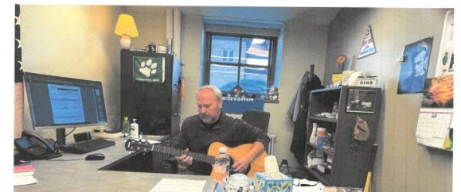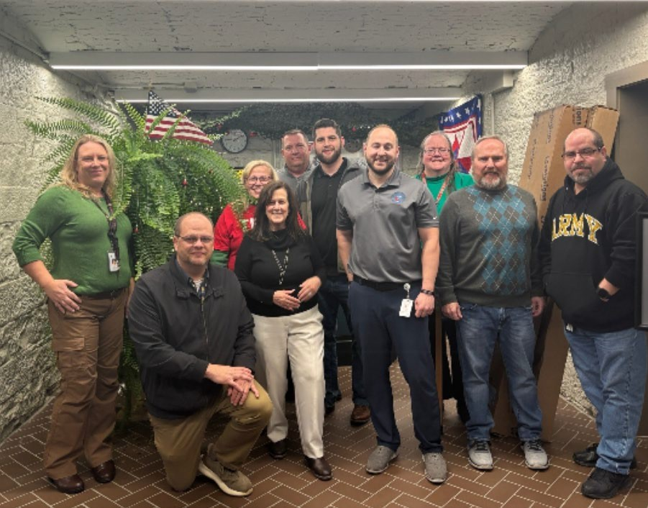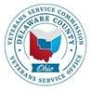

## OPEN HOUSE:

**April 2nd 2-4pm**

Note from Scott:

“As I wind down my time with Delaware County Veteran Services, I am so grateful for the relationships that have sprouted from the work we do. From helping Russ, a WWII Army Veteran wo went through the Battle of the Bulge and broke down in tears recounting the experience..to my friend Mac, a WWII/Korea Marine Vet who went through Chosin…to my friend Ken, a Special Forces Green Beret in Veit Nam…to my fellow Cold War Vets and all our Gulf War Vets- Thank you, for allowing us to help you! The memories I carry will always be dear to my heart and our relationships will always be a treasure to me, in this world and, I believe, in the next.”

**Recap of Winter**

*What have we done?*

Santa’s elves visit nursing homes

Wreaths Across America

**2025**

Coffee Talk with M.A.S.H

New Hires

Cemetery Records Clerk VSO

# What’s Coming in 2025?

Deputy Director retiring New CVSO hired- Derrick Info Cast

Facebook/ Website updates Parade – **Need Volunteers**

Veteran/ Veteran Friend – **Nominations**

VSO Volunteers- Visit Veterans, assist with events- **Apply online through county website SOON**

Homeless night walk

**Flyers**

